LAB 12: ALGORITHMS WITH AI ASSISTANCE
Srting, Searching, and ptimizing Algo

NAME : D.JAGADEESHG
ROLL NO : 2503A52372
BATCH : 13

Task 1: Merge Sort Implementation

Question
Write merge_sort(arr) to sort ascending, include time and space complexity in the docstring, and verify with test cases.

Prompt:
Generate a documented merge_sort(arr) with a merge helper. Include complexity and test empty, single-item, duplicate, and unsorted lists.

Python Code:
def merge_sort(arr):
"""Sort ascending. Time: O(n log n) in all cases; extra space: O(n)."""
if len(arr) <= 1:
return arr[:]
mid = len(arr) // 2
left = merge_sort(arr[:mid])
right = merge_sort(arr[mid:])
return merge(left, right)
def merge(left, right):
"""Merge two sorted lists."""
result = []
i = j = 0
while i < len(left) and j < len(right):
if left[i] <= right[j]:
result.append(left[i]); i += 1
else:
result.append(right[j]); j += 1
result.extend(left[i:])
result.extend(right[j:])
return result
if __name__ == "__main__":
for values in ([38, 27, 43, 3, 9, 82, 10], [], [5], [4, 2, 2, 1]):
print("Input:", values)
print("Sorted:", merge_sort(values))

Output :
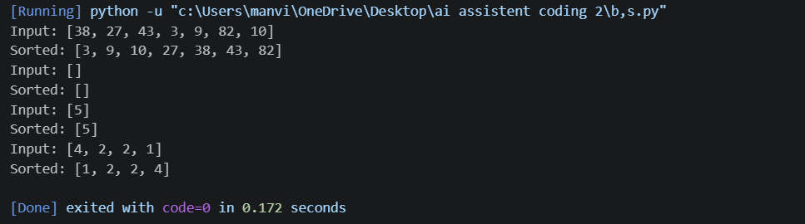

Justification:
Merge Sort uses divide-and-conquer. Time complexity is O(n log n) in best, average, and worst cases; auxiliary space is O(n). Tests include empty and duplicate values.
Run in VS Code terminal: python task1_merge_sort.py

Task 2: Binary Search with AI Optimization

Question:
Create binary_search(arr, target), returning the index or -1. Explain best, average, and worst-case complexities and test different inputs.

Prompt:
Implement iterative binary search on an ascending sorted list, return index or -1, document complexities, and test found and missing targets.

Python Code:
def binary_search(arr, target):
"""Search an ascending sorted list; return index or -1.
Best time: O(1); average/worst time: O(log n); space: O(1).
The input must already be sorted.
"""
low, high = 0, len(arr) - 1
while low <= high:
mid = low + (high - low) // 2
if arr[mid] == target:
return mid
if arr[mid] < target:
low = mid + 1
else:
high = mid - 1
return -1
if __name__ == "__main__":
numbers = [3, 8, 12, 17, 25, 31, 42]
for target in [17, 3, 42, 99]:
print(f"Target {target}: index {binary_search(numbers, target)}")

Output Screenshot:
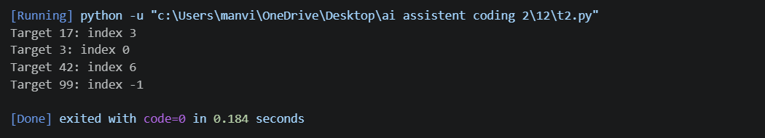

Justification:
Binary Search halves the search interval each step. Best-case time is O(1), average/worst-case time is O(log n), and iterative extra space is O(1). Input must be sorted.
Run in VS Code terminal: python task2_binary_search.py

Task 3: Inventory Management System

Question:
Search thousands of products by ID/name and sort by price/stock quantity. Recommend and justify algorithms considering dataset size, update frequency, and performance.

Prompt:
Implement product ID lookup, case-insensitive name search, and sorting by price/quantity. Add sample data, docstrings, complexity notes, and an algorithm selection table.

Code:
def search_by_id(products, product_id):
"""Average O(1) dictionary lookup."""
return products.get(product_id)
def search_by_name(products, name):
"""Case-insensitive exact-name search; O(n)."""
target = name.strip().casefold()
return [p for p in products.values() if p["name"].casefold() == target]
def sort_inventory(products, field="price", descending=False):
"""Sort by price or quantity in O(n log n)."""
if field not in {"price", "quantity"}:
raise ValueError("field must be 'price' or 'quantity'")
return sorted(products.values(), key=lambda p: p[field], reverse=descending)
if __name__ == "__main__":
inventory = {
"P101": {"id":"P101","name":"Notebook","price":45.0,"quantity":120},
"P102": {"id":"P102","name":"Pen","price":10.0,"quantity":500},
"P103": {"id":"P103","name":"Bag","price":650.0,"quantity":25},
"P104": {"id":"P104","name":"Notebook","price":55.0,"quantity":80}}
print("Search by ID:", search_by_id(inventory, "P103"))
print("Search by name:", search_by_name(inventory, "Notebook"))
print("By price:", sort_inventory(inventory, "price"))
print("By quantity:", sort_inventory(inventory, "quantity", True))

Output :
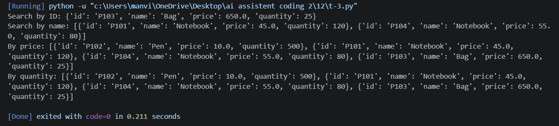
Justification: Dictionary ID lookup is average O(1); name scanning is O(n), with a secondary index useful for frequent name searches. Python sorted() uses Timsort and is O(n log n). Keep indexes current as products change.Run in VS Code terminal: python task3_inventory_management.py

Task 4: Smart Hospital Patient Management System

Question:
Search patient records by ID/name and sort by severity/bill amount. Recommend and justify algorithms, then implement them in Python.
Prompt:
Build patient ID/name search and sorting by severity or bill amount; include sample patient records and complexity documentation.

Code:
def search_patient_by_id(patients, patient_id):
"""Average O(1) lookup by patient ID."""
return patients.get(patient_id)
def search_patient_by_name(patients, name):
"""Return exact case-insensitive matches; O(n)."""
target = name.strip().casefold()
return [p for p in patients.values() if p["name"].casefold() == target]
def sort_patients(patients, field="severity", descending=True):
"""Sort by severity or bill_amount in O(n log n)."""
if field not in {"severity", "bill_amount"}:
raise ValueError("field must be 'severity' or 'bill_amount'")
return sorted(patients.values(), key=lambda p: p[field], reverse=descending)
if __name__ == "__main__":
patients = {
"H101":{"id":"H101","name":"Asha Rao","severity":5,"admission_date":"2026-10-12","bill_amount":18000},
"H102":{"id":"H102","name":"Rahul Das","severity":2,"admission_date":"2026-10-10","bill_amount":6500},
"H103":{"id":"H103","name":"Asha Rao","severity":4,"admission_date":"2026-10-13","bill_amount":12000}}
print("Search ID:", search_patient_by_id(patients, "H102"))
print("Search name:", search_patient_by_name(patients, "Asha Rao"))
print("By severity:", sort_patients(patients, "severity"))
print("By bill:", sort_patients(patients, "bill_amount"))

Output :
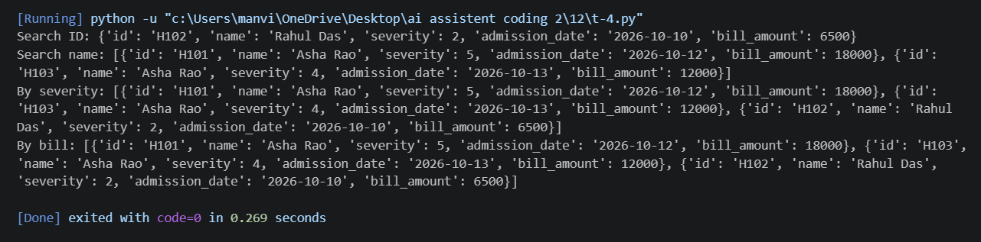Final Justification
A dictionary provides average O(1) ID lookup. Name search is O(n) unless a name index is maintained. Sorting severity or bill amount is O(n log n); highest severity is listed first by default.Run in VS Code terminal: python task4_hospital_management.py
Task 5: University Examination Result Processing System

Question
Search student results by roll number and sort students by marks for rank lists. Identify, justify, and implement efficient algorithms.
Prompt:
Use a dictionary keyed by roll number for lookup and sorted() for a descending marks rank list. Include sample students and print ranked results.

4. Complete Python Code
def search_result_by_roll(results, roll_number):
"""Average O(1) lookup by unique roll number."""
return results.get(roll_number)
def generate_rank_list(results):
"""Sort by marks, highest first; O(n log n)."""
return sorted(results.values(), key=lambda s: s["marks"], reverse=True)
if __name__ == "__main__":
results = {
"SRU101":{"roll":"SRU101","name":"Anil","subject":"Python","marks":91},
"SRU102":{"roll":"SRU102","name":"Bina","subject":"Python","marks":85},
"SRU103":{"roll":"SRU103","name":"Charan","subject":"Python","marks":96},
"SRU104":{"roll":"SRU104","name":"Divya","subject":"Python","marks":85}}
print("Search result:", search_result_by_roll(results, "SRU102"))
print("Rank list:")
for rank, student in enumerate(generate_rank_list(results), start=1):
print(rank, student["roll"], student["name"], student["marks"])

Output :
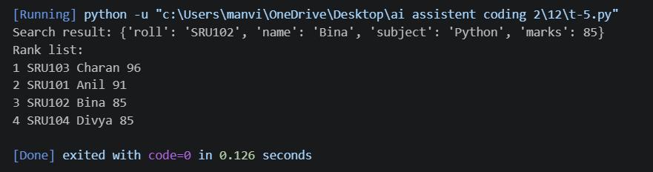

Justification:
Roll number is a unique key, so dictionary lookup is average O(1). Rank-list sorting is O(n log n); descending order places higher marks first.
Run in VS Code terminal: python task5_exam_results.py

Task 6: Online Food Delivery Platform

Question:
Find orders by order ID and sort orders by delivery time or price. Recommend optimized algorithms, justify the choice, and implement search/sort modules.

Prompt:
Implement dictionary order lookup and sorting by delivery time/price, with sample data, field validation, and complexity notes.

Code:
def search_order(orders, order_id):
"""Average O(1) lookup by order ID."""
return orders.get(order_id)
def sort_orders(orders, field="delivery_time", descending=False):
"""Sort by delivery_time or price in O(n log n)."""
if field not in {"delivery_time", "price"}:
raise ValueError("field must be 'delivery_time' or 'price'")
return sorted(orders.values(), key=lambda o: o[field], reverse=descending)
if __name__ == "__main__":
orders = {
"O501":{"order_id":"O501","restaurant":"Spice Hub","delivery_time":35,"price":280,"status":"Preparing"},
"O502":{"order_id":"O502","restaurant":"Green Bowl","delivery_time":20,"price":340,"status":"Out for delivery"},
"O503":{"order_id":"O503","restaurant":"Pizza Point","delivery_time":45,"price":520,"status":"Confirmed"}}
print("Search order:", search_order(orders, "O502"))
print("By delivery time:", sort_orders(orders, "delivery_time"))
print("By price high-to-low:", sort_orders(orders, "price", True))

Output :
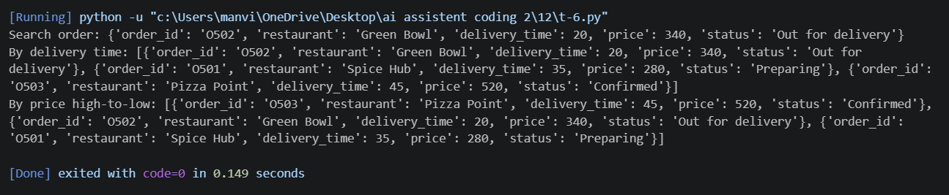

Justification:
Dictionary lookup by order ID is average O(1). Sorting by delivery time or price is O(n log n). Keep the order-ID dictionary updated and sort when a sorted view is needed.
Run in VS Code terminal: python task6_food_delivery.py

